1

ST. LAWRENCE CHURCH OF ENGLAND SCHOOL

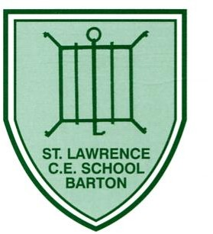

**Teaching, Learning and Feedback Policy**

**Written by Rachel Sharp - October 2022**

**Agreed by Governors: December 2022**

**Reviewed: October 2024**

Next Review: September 2026

**School Vision and Values**

*Learning together, rooted in God, pupils at St Lawrence Church of England Primary School are easy to distinguish by the personal qualities they present. They are* ***happy****,* ***confident, articulate*** *children with a love of learning and a sense of* ***service****, who recognise and celebrate their own* ***individuality*** *and that of other members of our community. They are* ***generous, kind*** *and welcoming; they are* ***forgiving*** *and understand* ***justice****. With God by their side, they face the world with* ***resilience****,* ***integrity*** *and* ***joy****.*

Contents:

1. Behaviour For Learning: Can my mind think well? Can my mind feel well?
2. Barton Curriculum Rationale and Educational Research
3. How We Teach Our Curriculum
4. Our Personalised Curriculum
5. Formative Assessment including Feedback
6. Classroom Environment at St Lawrence
7. The Role of Subject Leaders, Governors and Parents
8. Appendix

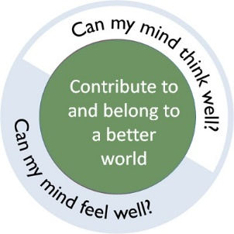

|  |  |
| --- | --- |
| **Can my mind think well?** | |
| **Pupils** | **Teachers and Leaders** |
| Communicate clearly: write, speak, and present ideas effectively in a variety of media within and across disciplines  Think critically: analyse, evaluate, and synthesise complex ideas and consider multiple perspectives  Make errors and see errors as a key part of their learning  Understand the purpose of the task and what they need to do in order to succeed  Create complex work: demonstrate higher-order thinking, multiple perspectives and transfer of understanding  Develop the skills to work collaboratively as well as independently  Apply their learning: transfer knowledge and skills to novel, meaningful tasks  Demonstrate proficiency and deeper understanding: show mastery in a body of knowledge and skills within each discipline  Demonstrate craftsmanship: create work that is accurate and beautiful in conception and execution  Create authentic work: demonstrate original thinking and voice, connect to real-world issues and formats, and when possible, create work that is meaningful to the community beyond the school | Ensure that curriculum, teaching and learning, and assessments are rigorous, meaningful, and aligned with standards  Have the subject knowledge to provide the next step in feedback  Engage all children in daily lessons that require critical thinking about complex, worthy ideas, texts, and problems  Plan deliberate interventions to ensure cognitive change and use a range of teaching strategies to provide direction and redirection  Move from single ideas to multiple ideas to enable students to construct and reconstruct knowledge and ideas  Use assessment practices that position children as leaders of their own learning  Use meaningful data for both teachers and children to track progress toward learning goals  Design tasks that ask children to apply, analyse, evaluate and create as part of their work  Use models of excellence, critique, and multiple drafts to support all children to produce work of exceptional quality  Connect children to the world beyond school through meaningful fieldwork, expert collaborators, research, and service learning |

|  |  |
| --- | --- |
| **Can my mind feel well?** | |
| **Pupils** | **Teachers and Leaders** |
| Work to understand emotions and feelings and their impact on behaviour  Develop mutual respect between themselves, adults in the school and parents/carers  Regard learning as a vehicle to personal enrichment and are motivated and enthused by their learning and have high self-esteem  Work to become effective learners: develop the mindsets and skills for success in college, career, and life (e.g. initiative, responsibility, perseverance, collaboration)  Work to become ethical people: treat others well and stand up for what is right (e.g. empathy, integrity, respect, compassion)  Contribute to a better world: understand their role and their agency as active citizens who can work for social justice, environmental stewardship and healthy, equitable communities (e.g., citizenship, service) | Prioritise social and emotional learning, along with academic learning, across the school  Elevate student voice and leadership in classrooms and across the school  Make habits of learning visible across the school  Model and promote a school-wide culture of respect and compassion  Create and maximise opportunities to build cultural self-esteem, cultural capital and promote diversity  Provide opportunities for children to become involved in projects which contribute to a better world  Support each other and feel confident to ask for help and support when needed |

# Barton Curriculum Rationale

# At Barton St Lawrence, we aim to give all pupils a strong academic foundation whilst developing the whole child: culturally, personally and spiritually. We provide all children with knowledge and skills that make them life-long learners, who have freedom of choice for how they can make a positive difference to our world. We strongly believe that all children can excel at something; and we provide a breadth of learning opportunities to ensure that each child’s special talent is honed. Our personalised, broad, balanced curriculum ensures that when children leave our school at the end of Key Stage 2, they have not simply learned the national curriculum, they have developed a level of expertise in an area of study for which they developed a passion. This is what makes a Barton learner.

# The rationale behind our curriculum design is supported by up-to-date educational research:

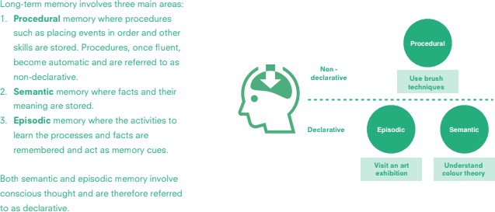Learning can be defined as a change to long-term memory. As Sweller and others have pointed out, ‘if nothing in the long-term memory has been altered, nothing has been learned’.

Our aims are to ensure that our pupils experience a wide breadth of study and have, by the end of each key stage, long-term memory of an ambitious body of procedural and semantic knowledge.

## Subject Schemata

Our curriculum is designed to help pupils form subject-specific schemata within their long-term memories. Schema theory states that all knowledge is organised into units. A schema is, therefore, a conceptual system for understanding knowledge. Each schema is a way of organising a subject's semantic and procedural knowledge in a meaningful way; it is an appreciation of how facts are connected and the ways in which they are connected. It is distinct from information, which is just isolated facts that have no organisational basis or links. Big Ideas help form the basis of the schema. Big Ideas are key concepts that underpin the subject. Each Big Idea has facets of knowledge (known to our pupils as knowledge categories) which help to strengthen the schema. Learning knowledge in each of the categories allows pupils to express and demonstrate their understanding of the Big Idea- the over-arching theme of the unit studied in a subject. These Big Ideas are returned to over and over again in different contexts so the pupils gradually build an understanding of them. (Appendix 1.1)

## How We Teach Our Curriculum

* Our curriculum design is based on evidence from cognitive science. Three main principles underpin it:
  + Learning is most effective with spaced repetition, where knowledge is rehearsed for short periods of time, over a longer period of time.
  + Interleaving helps pupils to discriminate between topics and aids long-term retention.
  + Retrieval of previously learned content is frequent and regular, which increases both storage and retrieval strength.
* In addition to three principles, we understand that learning is invisible in the short term and that sustained mastery takes time.
* Our curriculum content is subject specific. We make intra and inter curricular links to strengthen schema.
* Continuous provision, in the form of daily routines, replaces the teaching of some aspects of the curriculum and, in other cases, provides retrieval practice for previously learned content.
* Cognitive load theory is concerned with the architecture of the mind and brain, and in particular the capacity of the short-term memory to process information. The long-term memory consists of schemata (which are built up over time). Learning is essentially changing those schemata through acquiring knowledge and making connections with different schemata. However before entering long-term memory and developing schemata, information must first be processed through by the short-term memory or working memory. As this has limited capacity, retention of knowledge and development of schemata will not happen if the working memory is overloaded. Teaching in small chunks and not organising activities that requires too much memory capacity, until learners acquire knowledge that allows them to spend less time processing content.
* The time given to 'learning to talk' allows us to use talk as a vehicle for learning ‘talking to learn’. Maximising meaningful talk opportunities throughout the curriculum, helps deepen and embed learning.
* We place reading at the heart of our curriculum. Aiming to create life-long learners, we prioritise fluency; with it being a vital life skill and medium for accessing further education. High quality texts are provided to support and enhance the learning in all subjects. Subject leaders, in conjunction with English and Phonics leads, have ensured that the children have a broad and varied reading diet; and that subject-specific books follow an appropriate progression through school.

**Our Personalised Curriculum**

**We have designed a bespoke curriculum which is tailored to the needs of our children and is matched to the high aspirations we have for our school community. Subject leaders have designed overviews which identify the key knowledge our children are to gain as they progress through school. We have selected specific schemes to support our planning which are informed by effective pedagogy; the school vision and values; and which encompass the aims we have for our pupils by the time they leave our school.**

**Our Curriculum Golden Threads:**

1. **Our School Values**
2. **Global Citizenship**
3. **Spoken Language**
4. **Outdoor Learning**
5. **Essential Enrichment**
6. **Quality Texts**

**These threads are woven through our curriculum in its entirety, ensuring all of our pupils receive a truly holistic education. They underpin big concepts which are broken into small, sequential steps. This builds a deep body of knowledge over time which prepares them for further learning, future employment and life in modern Britain.**

**Every subject has been carefully planned to promote ambition for all members of our school community:**

* English:
* In English, a reading to writing teaching sequence is used for each unit of work. This is underpinned by spoken language through talk for writing activities being interwoven through each phase of the English units. Lancashire planning is used, but teachers have freedom to adapt them by selecting texts which allow for links to other subject areas to be made. Subject leaders monitor that a broad spread of Fiction, Non-Fiction and Poetry is provided in each term. Vocabulary is taught with vigor throughout English units using a broad range of maximum participation activities, which are also used in Guided Reading, as well as teaching key, subject-specific vocabulary across the curriculum. Grammar warm-ups at the start of each session drip feed the key skills for the year group. They are selected in accordance with the unit of English being studied so that they can be applied to writing. Teachers also use assessment information to plan revisits of grammar skills from previous year groups into these daily warm-ups. Talk for writing strategies, such as the ‘i model’ are used in daily grammar warm-up sessions. Letter formation is taught from Phase 2 in Red Rose Phonics, introducing joining from the end of Year 1 using Penpals progression. The progression from Penpals is used for handwriting from Year 1; however, teachers can supplement with any resources to support the teaching of the skills.

Guided Reading workshops focus on both word reading and comprehension skills. It is delivered in small groups so that the individual needs of children can be met so that high-quality texts are pitched correctly for the groups of children. Teachers select books, as well as poetry and non-fiction, which have suitably challenging plot structure (in fiction) and vocabulary. Reading response and analysis activities that have previously been taught in English sessions are used to provide children with high engaging pre-teach and follow-up sessions. Guided Reading is embedded on each class timetable, as an addition to Phonics (EYFS, KS1); and the shared and modelled reading that features in English units.

* Systematic Synthetic Phonics:

We use Red Rose Phonics (fully decodable books have been put into sets to ensure that children are reading books in which they have recently been taught the sounds in them). The scheme is taught with fidelity throughout school by ensuring that shared approaches are used throughout school e.g. Phonics fingers; starred Tricky Word cards; ‘New Learning’; ‘My turn, your turn’; ‘Pause, Prompt, Praise’, as well as a range of maximum participation activities. A demonstration video outlining our key approaches, which are in line with Red Rose Phonics, has been shared with all adults who read with children, including volunteers and parents, and have been shared on the website. Subject leaders have ensured our Phonics scheme is personalised and a broad and varied reading diet is provided for the children by selecting the scheme books in relation to the interests and needs of our children. Fidelity to the scheme is also evident in Phonics, Reading and Spelling interventions e.g. adapted Fast Track Phonics, Bounce Back Phonics, No Nonsense Spelling. Rigorous assessment of Phonics e.g. Phonics tracker, in the moment teacher assessment, allows for gaps to be quickly identified and addressed through intervention.

* Mathematics:

In Maths we follow the long-term overview from White Rose Maths. We have selected Mastery materials with the guidance and support from NNW Maths Hubs. Teachers supplement this progression with NCETM resources, Power Maths practice books and Twinkl Dive into Mastery to provide deeper learning opportunities. To recap previous learning with further stretch and challenge, we also use ‘learning by questions’ and ‘nrich’ mastery resources. We have also implemented a lesson sequence which embeds retrieval practice and effective AFL- ‘My turn, our turn, your turn’ (see appendix). Our teaching approaches in mathematics are underpinned by Quality First Teaching practices which develop children’s procedural fluency, presenting concepts using variation and through use of concrete, pictorial and abstract representation. We aim to develop adept mathematical thinkers who can continue to grasp complex concepts and apply them to breadth of mathematical problems in readiness for their next stages in their Maths mastery journey. The block structure of our mathematics curriculum, combined with embedded retrieval practice supports this.

* Geography:

Geography at Barton St Lawrence is informed by the interests and needs of our pupils. When topics were chosen, the top priority was to ensure that the subject allows for a spiralling increase of knowledge and understanding about the subject that also equips children with an understanding of the wider world around them. Some topics take into account the rich depth and breadth of Geography we have on our doorstep, while others are planned with the knowledge that the children in our school may not encounter the diversity or struggle that exists outside of their sphere of experience. It is our job in Geography to ensure that children are provided with both, as well as creating children who are curious and inquisitive about the world around them.

Each topic in Geography is justified by its relevance to the children in our school as well as the year group and time of year that it is being taught. For example, in Year 1, the children only study local and national areas and this is built up on in Year 2 where the children then look globally and start to build on the knowledge they previously have learnt. Children’s knowledge and understanding is assessed regularly with key questions to ensure that prior knowledge is being built upon when new ideas are introduced, allowing children to understand the significance of their geographical journey rather than seeing Geography as standalone units of learning. Each child is also assessed at the end of the each unit to see if they are above, below or at the expected standard for that topic. We are also incorporating a wider variety of vocabulary to ensure that children are equipped to understand new words at the start and throughout each topic. The children are then promoted to try and use these words whenever possible and express an understanding of the meaning and be able to use the word in context.

To support the teaching of Geography, staff have access to Oddizzi, which provides engaging resources and information for both staff and pupils. This can also be used as an assessment tool at the end of each lesson to use quizzes and further the children’s learning.

* Science:

Science at Barton St Lawrence is informed by the interests and needs of our pupils. Although the Science curriculum is planned out year by year by the government, the teachers have opportunities to deliver topics that are fun, engaging and allow our children to reach their full potential. Children at our school are very inquisitive and always want to find out more, so as a school, Science gives them that opportunity to work independently to find out the answers for themselves. Science is also

Working scientifically plays a huge role in Science at our school and ensures that the children have to come up with different ways of working things out and they work together in a group or individually. This promotes a more holistic child and provides children with different experiences that they needs to broaden their knowledge and understanding as well as more perseverance. Each Key stage allows the children to become more independent as they have acquired skills throughout the school, which help them to succeed. Science also have a very cross curricular link to Maths and Geography and the skills that are learnt are crossed referenced in to other areas of school. The 5 types of Scientific enquiry are also promoted around school and these allow the children to think about which element of Science they are covering and how they can achieve the end goal. These are also evident to see around school demonstrating the different parts of the curriculum that each class covers.

Children’s knowledge and understanding is assessed regularly with key questions to ensure that prior knowledge is being built upon when new ideas are introduced, allowing children to understand the significance of their Scientific journey. Each child is also assessed at the end of the each unit to see if they are above, below or at the expected standard for that topic. We are also incorporating a wider variety of vocabulary to ensure that children are equipped to understand new words at the start and throughout each topic. The children are then promoted to try and use these words whenever possible and express an understanding of the meaning and be able to use the word in context.

* Design and Technology:

Design Technology at Barton St Lawrence is informed by the interests and needs of our pupils and designed to spark interest, creative planning and ideas. The teachers provide topics that are fun and link to other areas of the curriculum. This allows children to transfer their knowledge and skills. Children are given opportunities to use taught skills and to develop the confidence to use their own ideas and experiment with different ways of designing and producing a product.

Allowing children to experiment with techniques allows the development of a trial and error approach where children learn that sometimes, getting things wrong is part of the problem solving process which can ultimately lead to success. They then learn to use what they have found out to develop their skills. Children are encouraged to review their own work and that of others in a constructive way.

Design Technology takes on a holistic approach to learning. The teaching of new skills, the development of existing skills and knowledge and the opportunity to put these into practice. This then leads to design and work to create something to meet the topic requirements. Children learn a wide variety of vocabulary within Design Technology projects which enables them to better vocalise different concepts. They are taught this vocabulary and encouraged to use it within their own work which embeds understanding.

Children’s knowledge and understanding is assessed regularly with discussion, open ended questioning and self evaluation. For children with learning, physical or developmental disabilities, there is always extra support from supportive adults, from time, extra guidance, one to one support or equipment to suit their specific need where possible. Practical steps can be simplified or extended to meet the interests and ability of children.

* Music:

The Barton St Lawrence Music curriculum is carefully planned to provide all pupils with a high quality music education which engages and inspires children to develop a life-long love of music, increases their self-**confidence**, creativity, and imagination, and provides opportunities for **individual**self-expression and a sense of personal achievement. We do this by progressively setting tasks that are open-ended and can have a variety of responses, but in a way that are carefully planned for through a curriculum that is sequenced to ensure that children build upon prior knowledge. We offer opportunities for children to develop their talents in all aspects of music including composition, singing and appreciation. Our vision is that children will develop an ability to listen to, and appreciate a wide variety of music, including different styles, periods and cultures and that they will have opportunities to explore and express, in **articulate**ways, ideas and feelings about music. Throughout school, children will explore a range of musical elements, for example: pitch, duration, dynamics, tempo, timbre, texture, structure and appropriate musical notations. We encourage active involvement in creating and developing musical ideas using voices and instruments – both tuned and un-tuned and develop a sense of group identity and togetherness through composing, rehearsing and performing music with others, to an audience. Singing lies at the heart of good music teaching and vocal activities are planned for each lesson, regardless of the objective.

Years 2, 4, 5 and 6 are currently taught by Broughton Music Academy. Tuition rotates between samba, recorders and glockenspiels. Ukulele tuition in Year 4 is soon to be introduced. All the intertwined musical elements are taught through this spiralling progression of skills and knowledge. EYFS, Years 1 and 3 are taught by the class teacher using the Charanga Model Music Scheme and also the Let’s Go Sing programme. The Charanga scheme is supplemented with additional compositional tasks and individualised activities planned for the turtle drums and boomwhackers.

* Art and Design:

At Barton St Lawrence, we believe that Art enables children to communicate what they see, feel and think. We have therefore planned a spiralling curriculum that allows children to experiment **creatively** with their ideas, their use of colour, texture, form, pattern and different materials and processes to produce unique pieces of work. Some units of work give children the opportunity to study the work of a famous artist or craftsperson in detail, whilst others focus more upon a certain subset of knowledge and skills. All units have been personalised to fit the needs of the children in our school and organised to follow a clear progression of skills and knowledge, through each year group and term. Self and peer evaluation of work is encouraged and children are taught not only how to **articulate**their feelings about their own work using specialist vocabulary but also how to be **resilient**to achieve their goals.

Children’s knowledge and understanding is formatively assessed throughout the learning process, through dialogue and conversation. Because we value learner’s creative and individual responses in the subject, we give open-ended feedback and use effective questioning techniques. Art is summatively assessed on a yearly basis using the key skills and knowledge outlined in the Medium Term Plans. The St Lawrence scheme of work is based around the following areas of assessment:

* Drawing and painting
* Skills in other media
* Knowledge of artists.
* Evaluating.

We use sketchbooks to record both experience and imagination, to help the children develop their ideas and to show progression in their artistic ability. Children are happy to work on their own and also to collaborate with others on projects in two and three dimensions and on small and large scales.

At St Lawrence, Art is not just taught in a designated art lesson, but wherever appropriate it is also linked to the wider curriculum as it gives children the opportunities to bring topics to life. We invite specialist artists in to work with the children, to inspire them and challenge their thinking and creativity. We give children the opportunities to visit museums and galleries, developing their skills of observation and evaluation as well as show the work of more able learners at the Open Exhibition at the Harris Museum. This further motivates children into becoming confident artists, ready for the next stage of education.

* History:

History at Barton St Lawrence is informed by the interests and needs of our pupils. When topics were chosen, the top priority was to ensure that the subject allows for a spiraling increase of knowledge and understanding about the subject that also equips children with an understanding of the wider world around them. Some topics take into account the rich depth and breadth of History we have on our doorstep, while others are planned with the knowledge that the children in our school may not encounter the diversity or struggle that exists outside of their sphere of experience. It is our job in History to ensure that children are provided both, as well as creating children who are curious and inquisitive about the world around them. Each topic in History is justified by its relevance to the children in our school as well as the year group and time of year that it is being taught in. Children’s knowledge and understanding is assessed regularly through the use of key questions to ensure that prior knowledge is being built upon when new ideas are introduced, allowing children to understand the significance of their historical journey rather than seeing History as stand alone units of learning. To support the teaching of History, Staff have access to Key Stage History - which provides engaging resources and ideas as to how history can be learned.

* Physical Education:

Lancashire planning provides the progression of skills and knowledge for PE across school. We enhance the provision with high-quality coaches and PE specialists from a range of local companies- this in turn provides teaching staff with high-quality CPD. Assessment is also built into Lancashire planning and informs teachers and the subject leader of children who are to be targeted for further support, or who are AGT, in different areas of PE. This informs the subject leader of which children can be selected to form teams in school, compete in competitions, or to be involved in inclusion festivals.

* Religious Education:

In RE we follow Questful RE. This syllabus was developed by Blackburn Diocese Board of Education and is a comprehensive syllabus broken down into units for each year group to cover. All of the resources are linked from the syllabus along with the assessment tool and ladder of expectations. By embracing the explicit teaching of Christian concepts and God’s big salvation story, it is hoped that the content of this syllabus will give pupils a deeper understanding of Christianity. In addition, pupils explore all major world faiths and discuss world views where appropriate.

* Forest School:

Our Forest School curriculum is planned to ensure it is personalised for our children and links with our curriculum topics. We are networking with another local school who have embedded outstanding forest school provision. We are adapting their progression to match the skills we want our children to focus on. School improvement planning gives this priority to be embedded this academic year.

* Computing:

Computing at Barton St Lawrence is planned to ensure that children leave our school equipped to handle the ever changing needs of the technological world around them. As children progress through school, units of learning provide them opportunities to explore many different software types, all with unique uses. Our aim is for children to leave Barton St Lawrence equipped to apply their understanding towards any of their interests or passions. Units are planned following the Purple Mash scheme of learning to support staff in delivering content to children confidently, with resources to support their subject knowledge and understanding of the software when needed. Units are sequenced to ensure that children build upon prior knowledge and cross - curricular links are explored wherever possible. Children in USK2 have the opportunity to apply their learning to different softwares to deepen their learning in other subject, for example creating persuasive videos (using their understanding of video editing software) in Literacy. Google Suite and Native iPad apps (iMovie etc) are  also used alongside the Purple Mash to support the teaching of computing where appropriate, to allow children to experience different softwares.

* Modern Foreign Languages:

At Barton St Lawrence, French lessons are planned using the Language Angels scheme. This scheme was chosen as it is especially well suited to non-specialist language teachers (in this case our Key Stage 2 class teachers), offering a huge amount of support with each lesson. This includes readymade PowerPoints, listening activities, written resources and detailed lesson plans with pronunciation guides. The scheme is thoroughly planned to meet the needs of the National Curriculum, covering the three pillars of language learning (phonics, vocabulary and grammar) and giving equal weight to the four skills of listening, speaking, reading and writing. Language Angels provides ambitious teaching resources, which are also differentiated to meet the needs of all pupils. The specific Language Angels units taught at Barton St Lawrence have been carefully selected to ensure that there is clear progression, but also that time can be spent consolidating the language introduced, as well as revisiting relevant prior learning. This has been a recent change in September 2022, moving from one unit per half term, to one unit per term. The order in which the units are taught considers prior knowledge required by pupils, as well as linking to topics which are being taught in other subjects in a year group at the same time. For example, Year 5 complete a French ‘Au Café’ unit in line with their ‘Food Glorious Food’ topic.

* PSHC&R:

PSHC&R is taught at Barton St Lawrence for one lesson a week across Key Stage 1 and Key Stage 2. We have purchased the Discovery Education teaching scheme which allows staff to access lessons and resources needed to support children and access the PSHC&R curriculum content. As a school, we felt that this scheme best supported the needs and information that pupils at our school have in PSHC&R. This scheme also allows for teachers to assess learning for pupils and has suggested tasks to further the learning for pupils who exceed in certain areas of the subject. Furthermore, the scheme allows staff and pupils to have a safe space for discussion and also shows clear progression in the curriculum content across year groups. Tasks and activities included in this scheme also allow pupils in our school to access learning in different ways. We also felt that our school values matched closely to the topics that we would be covering for each half term, further enhancing learning and understating for pupils, and therefore equipping them with the skills in the School’s vision and values. When deciding the order that topics would be covered throughout school, we felt that it would be best that the whole school covered the same themes across each half term so that the impact of what they learnt would be better across both key stages. We also felt that our pupils, having had a long break from others over summer, would benefit from learning and remembering the importance of friendships in Autumn term, which they could then implement throughout the rest of the year, and leave the school at the end of summer term feeling prepared for the new challenges and transitions to come in the following school year.

## Subject Knowledge Planners

Knowledge maps outline the procedural and semantic knowledge pupils will be taught in each knowledge category and are used to build the sequence of learning. Knowledge maps support teachers to maximise opportunities to make links across topics and subjects, helping to deepen an understanding of the Big Ideas. This provides a visible sequence of learning in the children’s books which provides them with an aide memoire as key knowledge is repeatedly revisited and built upon. (Appendix 1.3 Curriculum Overviews, Knowledge planners).

## Curriculum Milestones

Each Big Idea in each subject has been broken down into small sequential steps which build on the children’s prior knowledge. These are the key goals pupils are aiming for by the end of each unit. It takes time for pupils to demonstrate mastery or greater depth of the milestones. They need to gradually progress in their semantic strength and procedural fluency through three cognitive domains: basic, advancing and deep. As part of the progression model a different pedagogical style is used in each of the cognitive domains of basic, advancing and deep. This is based on the research of Sweller, Kirschner and Rosenshine who argue for direct instruction in the basic domain and problem-based discovery in the deep domain. (Appendix 1.2 Medium Term Plans) *

Each subject’s curriculum planning documents help pupils meet the milestones by providing:

* clearly defined subject topics to study which ensure curriculum breadth
* the knowledge needed to build a schema
* the vocabulary needed to articulate an understanding of the subject
* an outline of appropriately pitched (cognitive domain) tasks to carry out to show proof of progress

## Cultural Capital

Our curriculum content ensures our pupils the vital knowledge required to be informed and thoughtful members of our community who understand and believe in British values. Global Citizenship is planned into all of our units of work in Foundation subjects and Science. This contributes to our Christian-driven school vision and values underpinning our curriculum as a whole.

Our curriculum is enhanced through the provision of a breadth of learning opportunities: utilising our fantastic outdoor facilities; planning varied trips to museums, galleries and theatres in cities such as Manchester and Preston; and inviting inspirational visitors into school to allow the children to experience their learning through different perspectives.

## Cultural Self-Esteem

Our curriculum celebrates and reflects the backgrounds of our pupils at Barton St Lawrence and promotes cultural self-esteem. We promote community cohesion through working closely with our church; harnessing mutually beneficial relationships with local businesses (particularly through the work of our very proactive PTFA); and utilising our local, rural environment to enhance our studies on the local area. Our children feel proud of who they are, and the community they are part of, in being a St Lawrence pupil.

## Oracy

Research states that improved oracy is linked to academic success but also in its role in developing pupils’ sense of agency. Our curriculum in its entirety is underpinned with spoken language. We actively teach the skills needed to be an effective speaker ‘Learning to talk’. Subject leaders have broken down the national curriculum objectives on spoken language into small steps and planned these into each unit of work.

## Formative Assessment including Feedback

Hattie states that one of the most effective teaching tools is feedback which is bespoke and given as close to the point of learning as possible. At Barton St Lawrence, we have adopted a bespoke framework for giving ‘in the moment’ feedback, as we believe this is most impactful on our pupil’s learning. (Appendix 1.4 Feedback framework and marking codes)

Teachers will:

* Provide opportunities for practice enabling successive refinement, with room to make and correct errors as this will help them to improve their performance.
* Ensure lessons are well-paced but sensitively balanced to ensure the need for pace does not compromise the quality of the learning experience.
* Ensure lessons are appropriately planned to the level of learning.
* Listen and ‘read the room’ during a lesson and adapt the lesson accordingly and not just follow the plan. They will develop the skills to be able to scan, identify opportunities and barriers to learning; and address these through mini plenaries, one to one/group feedback ‘in the moment’, or, if necessary, before the next lesson so that all children are able to continue to access learning appropriate for their year group.
* Ensure that they and support staff proactively make use of formative assessment by addressing misconceptions in a timely manner e.g. teachers/TAs give timely intervention to children who need it in order to access the new learning in the next lesson.
* Provide effective whole class and (where appropriate) individualised feedback which ensures the pupils:
  1. Understand what they have done well.
  2. Are clear about how to improve.
  3. Make visible signs of improvement.
* Ensure teachers/TAs work in partnership with the SENCO and parents and children with SEN or additional needs to develop Individual Learning Plans or Pupil Passports (completed and reviewed half termly on Edukey). The provided format for planning and reviewing provision is used to ensure that formative assessment informs when SMART targets need to be updated.
* Summative assessment informs termly individual targets for each child (Maths, English and General in Target Booklet).

Feedback teachers and support staff provide will help to reduce the ‘gap’ between where the child is and where they are meant to be in terms of year group expectations. Teachers will differentiate their feedback taking into account the ability of the child to be able to independently respond to feedback and make improvements; and where in the teaching sequence they are working. It is most effective when there is clear alignment between teacher and child as to how both perceive the feedback given. Crucially, teachers must be clear on how any feedback has been received - is it having visible impact? And, is it building motivation to succeed in relation to the key knowledge and skills being learnt?

## Classroom Environment at St Lawrence

Psychological classroom environment Teachers will:

* Create a class climate that is seen to be fair.
* Actively encourage the phrase ‘I don’t know- yet’ and errors as routes to learning.
* Establish clear routines that will maximise learning time.
* Have clear expectations of behaviour and children that respect the teacher.
* Ensure children know that the teacher is passionate and believes in them.
* Use positive behaviour management techniques, underpinned by a restorative approach, effectively.
* Teachers will use the agreed Quality First Teaching approaches in all areas of teaching to ensure that all learners can access age-appropriate curriculum content; and that all learners are challenged to reach their full potential. (See Appendix).

Physical classroom environment Teachers will:

* Ensure classrooms are tidy and clutter-free and children are taught to take care of, select and return resources appropriately.
* Ensure key displays are current and support and enhance the children’s learning.
* Establish ‘working walls’ and ensure that they are well maintained and reflect the sequence of learning in topics/units.
* Ensure that resources and furniture are accessible and used imaginatively.
* Create corridor displays that are attractive and celebrate children’s achievements throughout the curriculum and reflect positively the diversity of children’s experiences and backgrounds.
* Ensure that tables and chairs are organised flexibly to encourage collaborative and independent learning.
* Ensure classrooms are safe and accessible to meet the needs of all children.
* Ensure each classroom has an inviting reading corner, which raises the profile of varied and challenging texts.
* Ensure all exercise books are labelled and encourage pupils to follow the presentation policy (Appendix: Presentation).
* Ensure EYFS and KS1 classrooms’ continuous provision supports and furthers the learning of the children and is in line with Step Into Quality.
* Ensure each class has a brick-backed vocabulary wall that is used to facilitate the interactive teaching of key vocabulary for subjects.
* Ensure all classrooms have a worship table which includes interactive activities to facilitate a space for reflection and prayer for the children. Ensure a class RE and Worship scrapbook are developed and is accessible to the children to use for reflection and revisiting learning.
* Ensure all classrooms have a copy of The Big Frieze displayed which is referred to in worship and RE lessons to place bible teachings within the context of God’s Big Story.
* Ensure other adults (TAs and volunteers) are directed by the teacher in planning to facilitate learning using agreed shared approaches. Other adults play an integral part in facilitating and furthering children’s learning without over-prompting.
* Ensure all adults model and promote high standards of spoken English.
* Ensure teaching or support staff use formative assessment to provide timely intervention.

**The Role of Subject Leaders at St Lawrence**

Subject Leaders have responsibility of leading part of the curriculum in conjunction with the curriculum leader. They:

* Support staff CPD to provide quality teaching in their subject.
* Provide resources to facilitate and enhance the teaching and learning of their subject.
* Monitor standards in their subject using a variety of monitoring tools to inform action planning.
* Develop action plans to inform school improvement planning for curriculum. Regularly review these plans and share progress and priorities with governors and SLT.
* Model high standards of teaching practice in their subject areas.
* Raise the profile of their subjects by providing curriculum enhancements such as, visitors, experience days, whole school curriculum days, trips, outdoor learning opportunities.
* Ensure a coherent curriculum is embedded which plans the progression of knowledge, skills and key vocabulary.
* Work collaboratively with the curriculum leader and other subject leaders to ensure links across subjects and year groups are planned for within each sequence of learning; that links to global citizenship are interwoven into curriculum content; and that spoken language objectives are planned into each unit of work (Spoken Language LPDS document).
* Liaise with Early Years and local Secondary school practitioners to gain understanding of the foundational and future learning of our pupils.
* Ensure that assessment is used effectively in their subjects to inform next steps for learning to ensure an individualised curriculum is embedded.
* Ensure a progression of high quality texts and resources to support and deepen the learning of their subject is provided through school.

## The Role of Governors at St Lawrence

Our governors support, monitor and review the school’s approach to teaching and learning. In particular they:

* Monitor the effectiveness of the school’s teaching and learning approaches through the school’s self-review processes, which include reports from subject leaders, the head teacher’s report to governors and school visits.
* Ensure that the school buildings and premises are used optimally to support teaching and learning and are compliant with health and safety regulations.
* Seek to ensure our staff development and our performance management both promote quality first teaching.
* Seek to ensure that staff well-being is considered in all of school’s endeavours to be successful and thriving.
* Monitor how effective teaching and learning strategies are in terms of raising pupil attainment.
* Monitor the school with regard to meeting the needs of the community it serves.

## The Role of Parents at St Lawrence

Parents have a fundamental role to play in helping children to learn. We inform parents about what and how their children are learning by:

* Holding induction meetings to explain our school strategies for teaching the National Curriculum and Early Years Foundation Stage Curriculum to new parents.
* Sending information to parents at the start of each term in which we outline the curriculum that the children will be studying during that term at school.
* Providing termly reports and updates to parents in which we explain the progress made by each child.
* Explaining to parents how key areas of the curriculum are taught through holding workshops, sending out information and having a ‘meet the teacher’ night at the start of the year.
* Holding parents’ evenings that provide an opportunity to discuss the progress that children are making.

Parents have the responsibility to support their children and the school in implementing school policies by:

* Ensuring that their child arrives at school on time and has the best attendance record possible, which includes avoiding taking holidays during term-time.
* Ensuring that their child is equipped for school with the correct uniform and PE kit.
* Informing school if there are matters outside of school that are likely to affect a child’s performance or behaviour.
* Promoting a positive attitude towards school and learning in general.
* Fulfilling the requirements set out in the home-school agreement.

Appendix

* 1. Example yearly overview

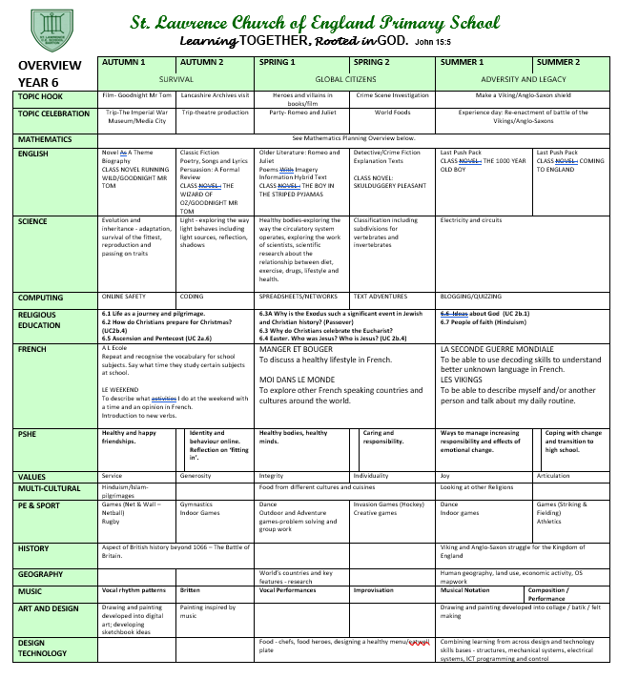

Appendix 1.2

Example subject overview (medium term plan)

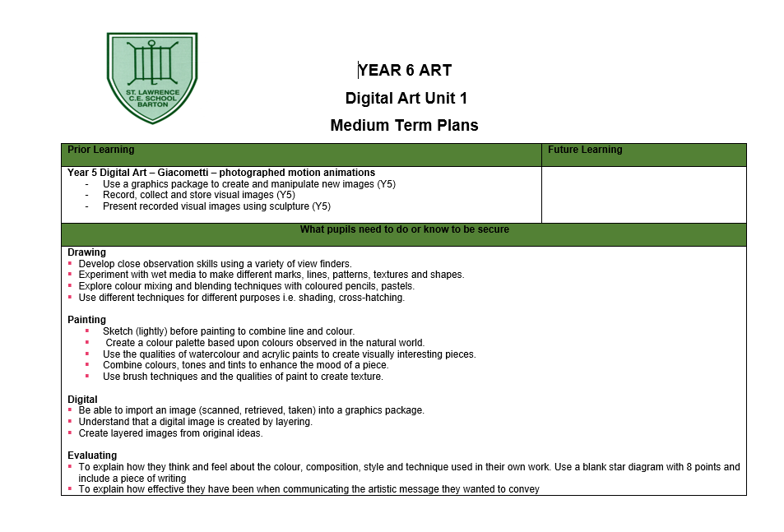

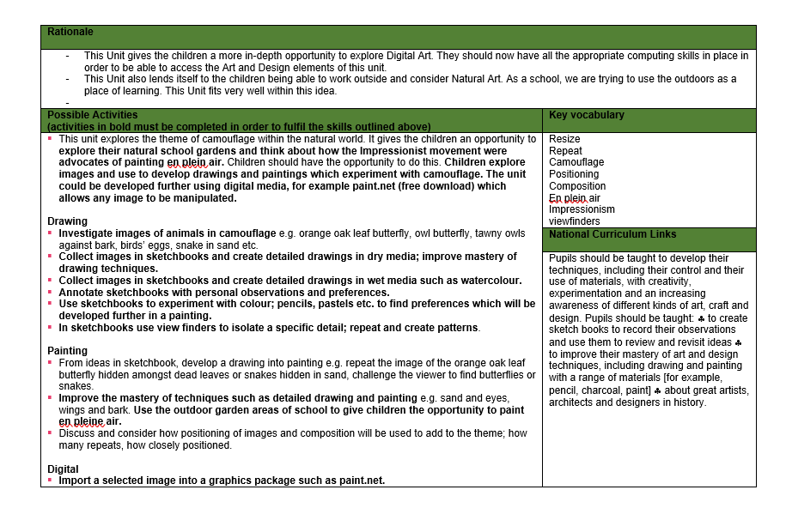

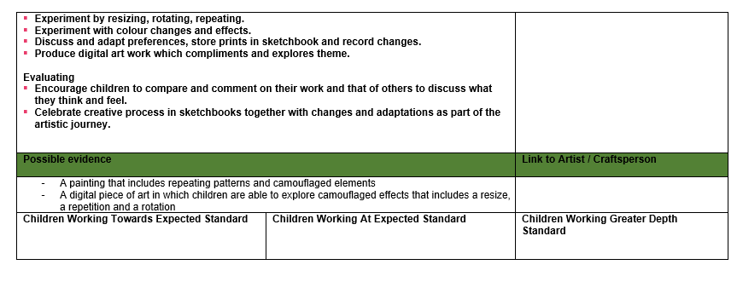

Appendix Knowledge planner, Curriculum teaching sequence (unit/ lesson)

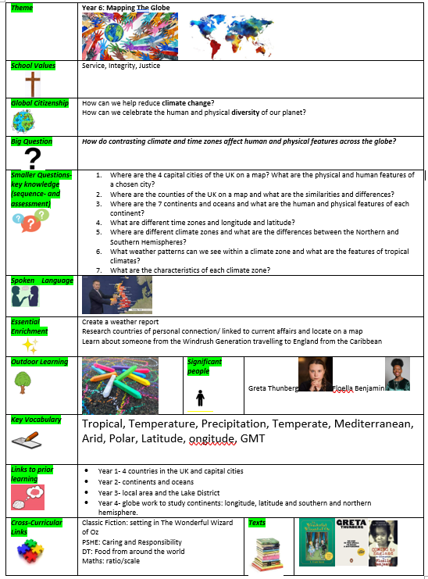 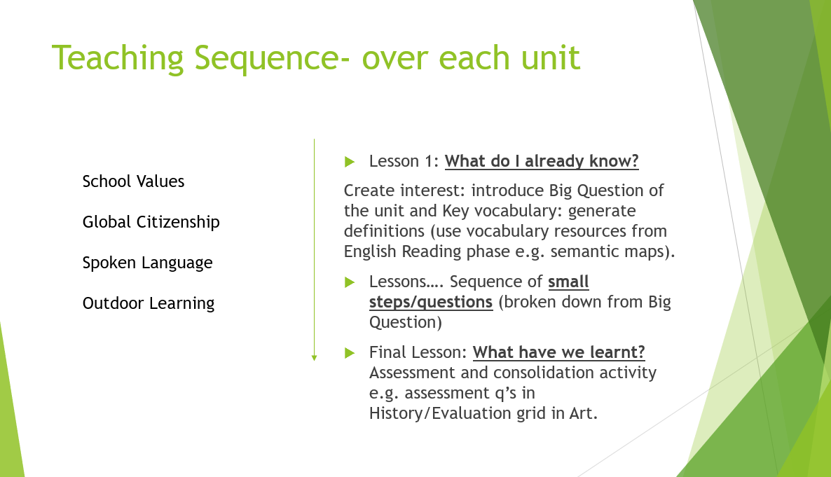

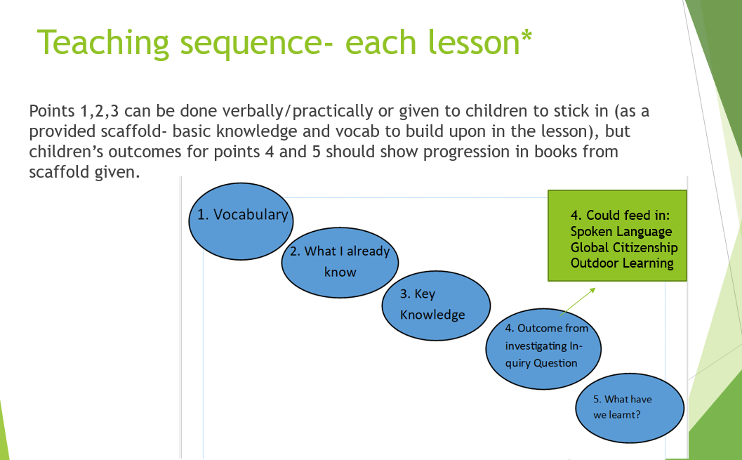

Appendix 1.4

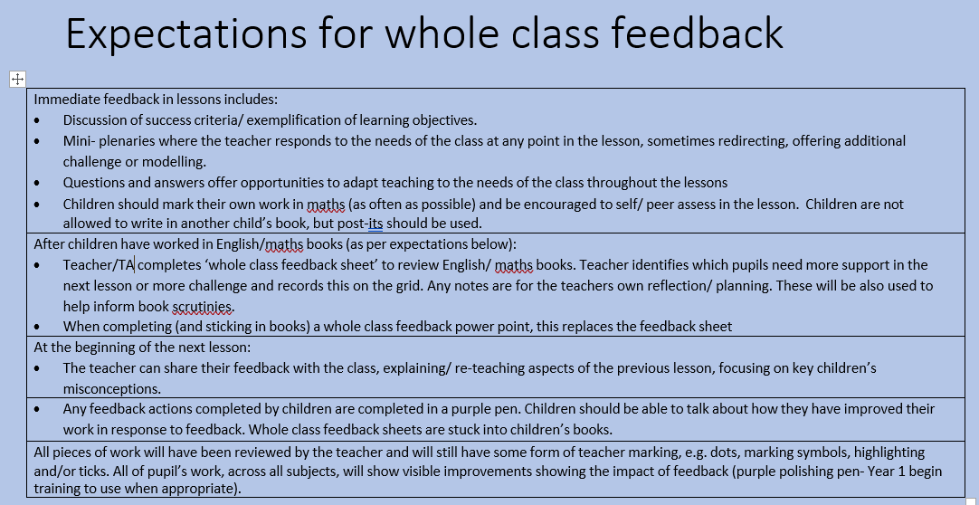

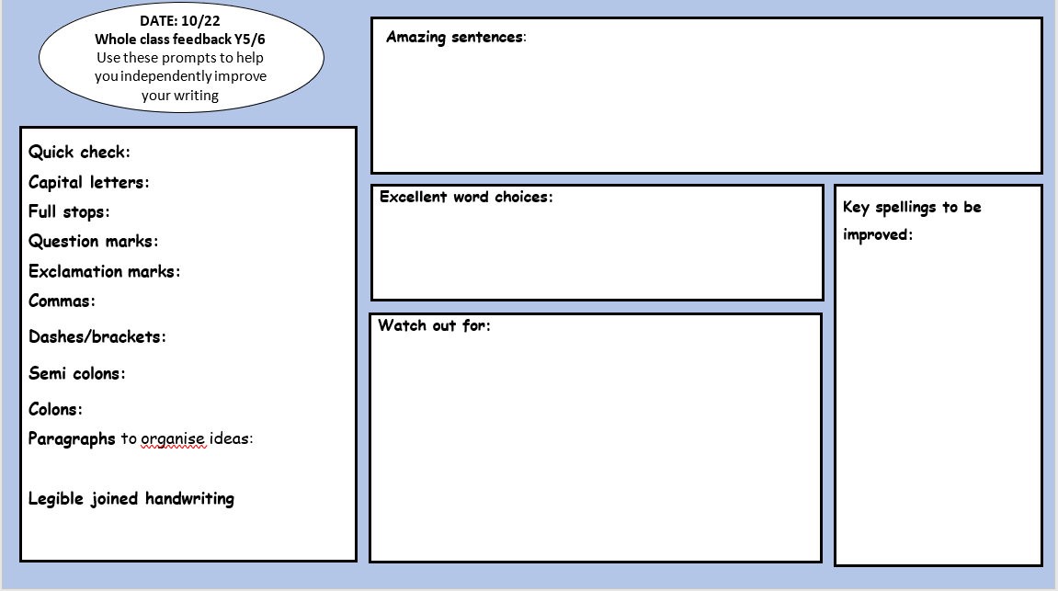

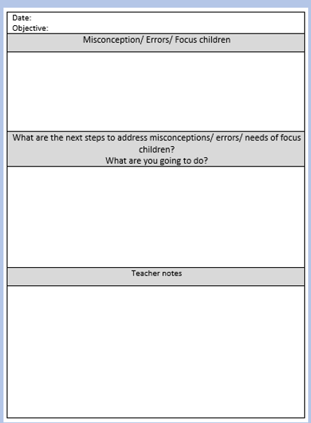

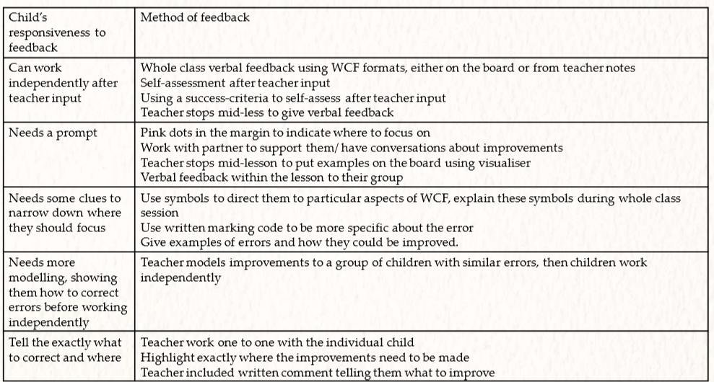

Marking codes

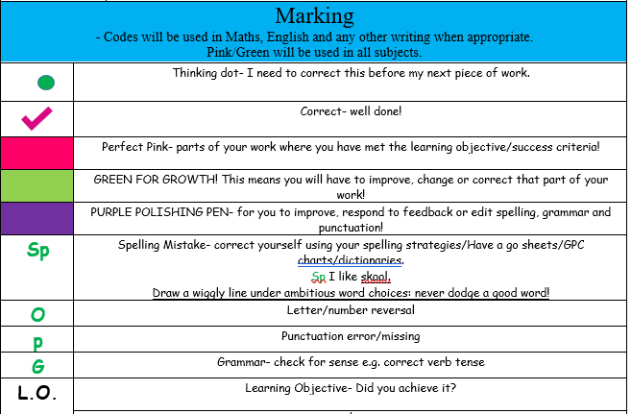

Presentation

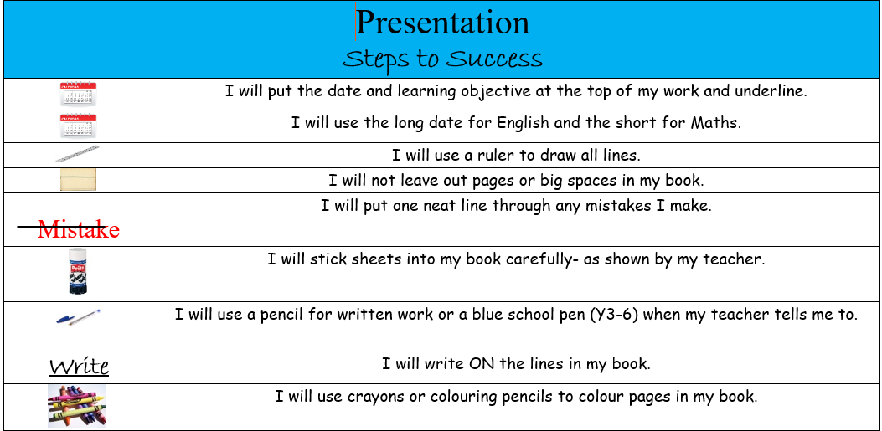

Appendix 1.5 Art work sample and evaluation grid

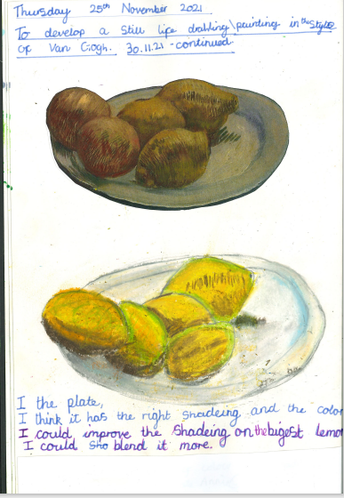 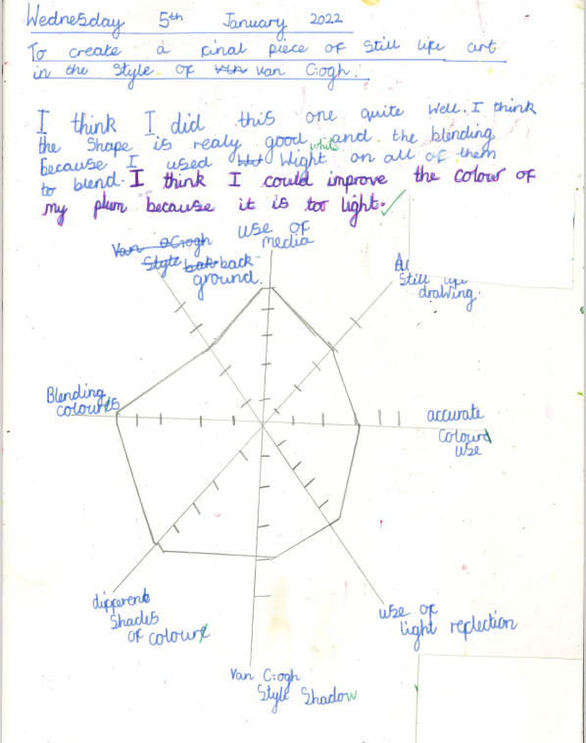

Appendix: Quality First Teaching

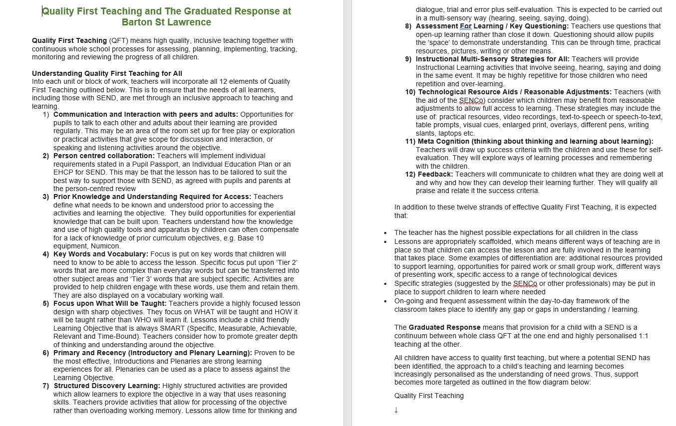

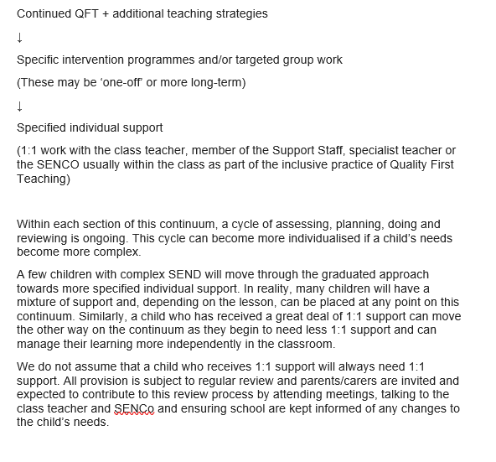

Mathematics lesson sequence:

1. Flashback 4 (retrieval practice- a range of concepts from learning that has occurred before the current block).
2. Starter (including retrieval practice in the form of a recap of prior learning from the current block).
3. New learning: new knowledge introduced as a small step and taught using structure: My turn, your turn, our turn.’ Stem sentences used for explicit vocabulary teaching throughout.
4. Dong Nao Jin – non-concept- hard thinking practices (as plenary or peppered throughout teaching sequence e.g. True or false.)