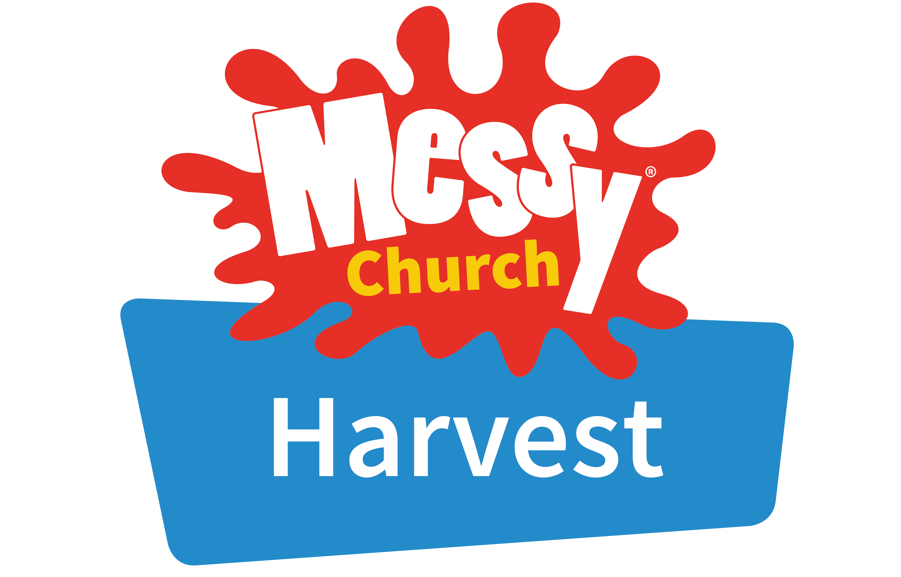

**MESSY CHURCH –** **Thursday 17th October**

**from 3.45pm in Year 5 Classroom**.

Messy Church enables people of all ages to belong to Christ

together through their local church.

It is a way of being church which is particularly suited to families,

but welcoming to all ages.

It meets at a time and on a day that suits local families

and is particularly aimed at people who have never belonged

to a church before.

Each session lasts an hour and includes food, story, music, crafts, games, activities and are always so much fun.

**It is free of charge and everyone is welcome!**

(Children must be accompanied by an adult)