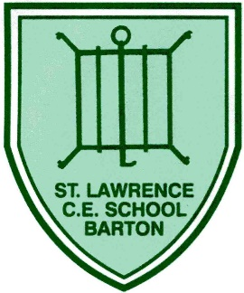
Barton St. Lawrence Primary School

Yearly Overview

 | AUTUMN 1 | AUTUMN 2 | SPRING 1 | SPRING 2 | SUMMER 1 | SUMMER 2
RECEPTION | FMS –  Rumble in the Jungle | FMS –  Superworm | FMS –  Hungry Caterpillar | FMS –  Elmer | FMS –  How to catch a star | FMS –  Rosie’s Walk  & Rugby Tots
YEAR 1 | Baseline unit - Supertato | Gymnastics Activities 1 | Rolling a ball | Catching & bouncing a ball | Kicking | Rugby Tots
 |  |  | Underarm throw | Dance – Robots | Overarm throw | Athletics
YEAR 2 | Piggy in the middle | Bounce ball | Dance – Explorers | Striking and fielding | Rugby | Net and wall
 | Playground games in the 20th Century |  | OAA – The Great Outdoors | Athletics | Gymnastics Activities | End of KS1 assessment
YEAR 3 | Invasion Games - Handball | Invasion Games - Netball | OAA – Team work & problem solving | Athletics | Net and wall – Core Task 2 | Striking & Fielding - Rounders
 | Target Games – Dodgeball | Gymnastics activities 1 | Gymnastics activities 2 | Invasion Games - Rugby | Dance – Ironman | Dance – Rock and Roll
YEAR 4 | OAA – Trust and Trails | Gymnastics activities 2 | Invasion Games - Basketball | Invasion Games - Rugby | Striking & Fielding - Cricket | Dance – The Great Plague
 | Swimming – Autumn 1 | Swimming – Autumn 2 | Swimming – Spring 1 | Swimming – Spring 2 | Swimming – Summer 1 | Athletics
YEAR 5 | Invasion Games - Netball | Gymnastics Activities 1 | Target Games – Curling | Dance – Food, glorious food | OAA - Orienteering | Striking & Fielding - Rounders
 | Invasion Games – Rugby 1 | Gymnastics Activities 2 |  | Invasion Games – Hockey | Net and Wall – Tennis | Athletics
YEAR 6 | Invasion Games – Hockey | Invasion Games – Rugby 2 | Dance – Heroes and villains | Net and Wall - Badminton | Dance - Seaside | Target Games – Curling
 | OAA – Team Building | Gymnastics Activities 1 | Athletics | Gymnastics Activities 2 | Striking & Fielding – Cricket

