Theme | Year 3: Printing
School Values  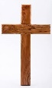 | Individuality
Global Citizenship | How can we empower women? Link to Mary Anning.
Big Question | How do we create a large scale print of dinosaur fossils including a repeating pattern and rotations?
Smaller Questions- key knowledge  (sequence- and assessment) | - How do we create an observational drawing using a range of dry media?  - How do we create a large-scale watercolour painting of a fossil?  - How do we create a simplified motif of an image of a fossil?  - How do we transfer a motif to a quick-print polystyrene block using the impressed method?  - How do we print a repeating pattern with rotations using the impressed method?  - How do we create a relief-printing block and print using this method?  - How do we evaluate our work using a star diagram and identify changes for future work?
Spoken Language | 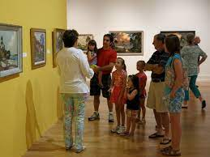
Essential Enrichment | Art exhibition tour  Interview between Artist and Art reviewer
Outdoor Learning | Hold the Art Exhibition outside – after school for parents? | Significant people | Eric Gill 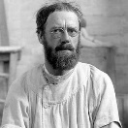Japanese printmakers 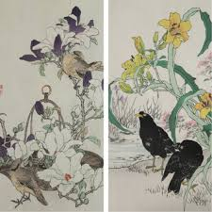
Key Vocabulary | Quick-print, motif, repeating pattern, impressed method, rotation, large scale
Links to prior learning | Year 2 Printing Cityscape  Build repeating patterns and recognise pattern in the environment (Y2)  Make a printing block using the impressed method (Y2)  Design more repetitive patterns (Y2)  Experiment with overprinting motifs and colour (Y2)
Cross-Curricular Links | Science – how are fossils made? |  | Texts | 